Name:_______________________ Group:_________

Cell Cycle Study guide
Pages 61 – 68

- TEST IS ON WEDNESDAY DECEMBER 3RD

- Study the vocabulary list

- Study the Cell Cycle

- Cell cycle explains how the cells in our bodies divide to produce more cells for: Growth, repair, healing, etc.

- Cell cycle is divided into 3 stages and 4 phases
- 3 Stages:
  - Interphase – DNA must be replicated, cell gets ready for division
  - Mitosis – which is the division of the nucleus into two, has
4 Phases: Prophase Metaphase Anaphase Telophase
3. Cytokinesis – the cell is split into 2 separate cells called
daughter cells

- Remember, DNA has 3 different names
- Chromatin - DNA during Interphase, thread-like
- Chromosome – condensed DNA during Mitosis, in humans
there are 46 chromosomes or 23 pairs
- Chromatid - one of the 2 strands that make a chromosome,
Chromosomes are shaped like letter “X”

- DNA is made of 4 Nitrogen bases, sugar and phosphate group
a. Nitrogen bases always pair up this way:
Adenine (A) - Thymine (T)
Cytosine (C) - Guanine (G)

- DNA replication - DNA makes exact copy of itself before cell division

- Mutation – mistakes during DNA replication
a. Base pairs are matched incorrectly ex: Cytosine with Adenine
b. Mutations cause diseases including Cancer

NOTE: DO NOT LOOSE THIS STUDY GUIDE
BEGIN STUDYING NOW, DO NOT WAIT UNTIL THE NIGHT BEFORE
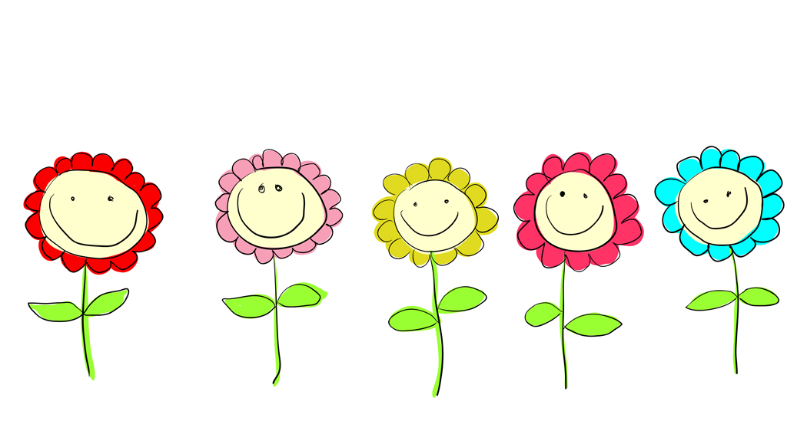
GOOD LUCK!!!!!!

