The Periodic Table of Elements Questions

Name:_________________________ Date:__________ Group:___________

Slide 3
- What is the purpose of the Periodic Table?____________________________________
____________________________________________________________________________________________________________________________________________________________________________________________________________
Slide 4
- Why is Periodic Table important?__________________________________________
____________________________________________________________________________________________________________________________________________________________________________________________________________
Slide 6
- Take a look at a Periodic Table. Can you figure out how the elements are arranged?
Hint: Think about what you have learned already about the atoms of each element…!
___________________________________________________________________________________________________________________________________________________________________________________________________________
Slide 7
- The periodic Table is organized in 2 ways.
- ________________________________________________________________
- ________________________________________________________________
________________________________________________________________
Slide 8
- The _____________________________ and are labeled from 1 to 7.
The _______________________________ are labeled from 1 to 18.
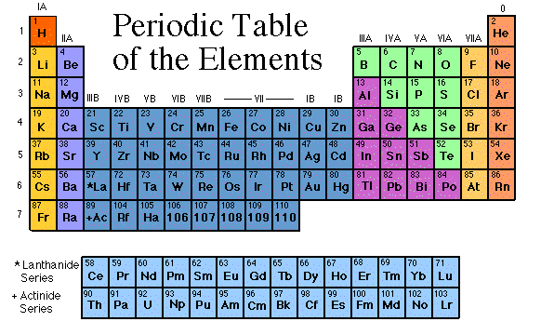
Slide 10
- What do Elements in the same Group have in common and why?
- ________________________________________________________________________________________________________________________________
- ________________________________________________________________________________________________________________________________
- _______________________________________________________________________________________________________________________________
Slide 11
- What are Valance Electrons and what do they cause?_____________________________
________________________________________________________________________________________________________________________________________________________________________________________________________________________________________________________________________________
Slide 12
- What are Ions?
- ________________________________________________________________________________________________________________________________
- ________________________________________________________________
Slide 13
- What are Anions? _______________________________________________________
____________________________________________________________________
- Why do they have the negative charge?______________________________________
________________________________________________________________________________________________________________________________________
Slide 14
- What are Cations? ______________________________________________________
____________________________________________________________________
- Why do they have the positive charge?______________________________________
________________________________________________________________________________________________________________________________________
Slide 15
- Families are columns in the Periodic Table True or False
- Another name for families is ________________________
- What are Valance electrons?_____________________________________________
____________________________________________________________________
- How many Groups or Families are in the Periodic Table?__________________________
Slide 16
- Hydrogen belongs in it’s own Family or Group True or False
- Which famous explosion was Hydrogen involved in?_____________________________
- What can Hydrogen be used for?__________________________________________
____________________________________________________________________
Slide 17
- What is the name of Group 1 Family?________________________________________
- Are the elements in this Family reactive?____________________________________
- Name a substance formed from this group?______________ which is ______________
Slide 18
- The name of the 2nd Group Family is?______________________________________
- Reactive metals that are always combined with _______________________ in nature.
- Calcium and Magnesium are two nutrients found in_____________________________
___________________________________________________________________
Slide 19
- Transition Metals can be found in groups?______________________
- These metals are used in ______________________ and ___________________
Slide 20
- Group 13 is the ___________________________Family
- Name 2 elements in this group and how are they used?
- ___________________________________________________________
- ___________________________________________________________

Slide 21
- Group 14 is the __________________________________________
- Carbon has its own branch of chemistry True or False
- A very special Carbon that we all love is the ________________________________
Slide 22
- This Family is named after an abundant gas that makes up 3/4 of our atmosphere called?
__________________________________
- Which Group can this Family be found in?_____________
- Where is Phosphorus used?_____________________________________________
Slide 23
- This Family in Group 16 is named after an element we all need to live called?
_____________________________
- The “stinky” Sulfur can be found in which things?
__________________________________________________________________
Slide 24
- Name 2 properties of elements found in Group 17 Halogens.
____________________________________________________________________
- Name 2 uses of Halogens_________________________________________________
____________________________________________________________________
- Iodine, an important nutrient for growth is found in which foods? List 3-4 examples:
________________________________________________________________________________________________________________________________________

Slide 26
- What is a special property of Noble Gases in Group 18?
__________________________________________________________________
- Another name for Noble Gases is the ___________________Gases
- An everyday use of Helium in___________________________________________
Slide 27
- What are the 3 main categories in the Period Table?
- ____________________________________
- ____________________________________
- ___________________________________
- Which category has the most elements?____________________________________
- Which category has the least number of elements?____________________________
Slide 29
- Name 5 properties of Metals
- ________________________________________________________
- ________________________________________________________
- ________________________________________________________
- _______________________________________________________
- _______________________________________________________
- Explain what is Ductile__________________________________________________
____________________________________________________________________
- Malleable metals can be________________________________________________
__________________________________________________________________
- Corrosion is a type of ___________________________property
Slide 30
- Name 5 properties of Non - Metals
- ________________________________________________________
- _______________________________________________________
- _______________________________________________________
- _______________________________________________________
- _______________________________________________________
- Many Non-metals are gases? True or False

Slide 31
- Metalloids (______________________) have properties of both _______________ and ______________________
- They can be Ductile and Malleable True or False

