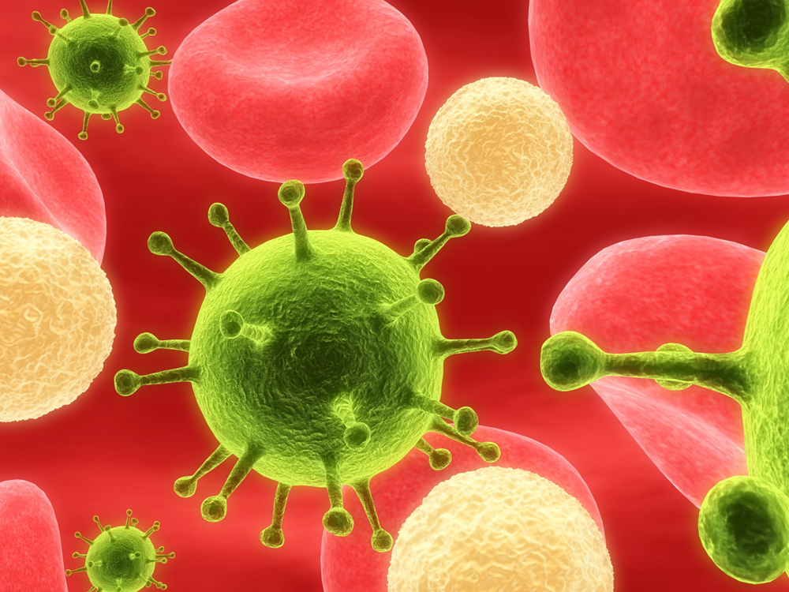
Pathogens and Immune System Study Guide
Pages 48 – 65 in science book
Read Study Guide on pg. 75

- Study the vocabulary words from Bacteria and Viruses packets

BACTERIA
- 3 basic shapes:
- Spirilla
- Rod- like
- Cocci/sphere
  - Bacteria are simple, prokaryotic cells
  - Bacteria are treated with Antibiotics
  - Many bacteria are becoming resistant to antibiotics called “SUPER BUGS”
  - Only 1% of bacteria are harmful or pathogenic
  - The “GOOD” bacteria are used in
- Food production – cheese, yogurt
- Make VITAMIN K
3. Environmental cleanups
- Bacteria reproduce asexually by “Binary Fission”
- Some bacteria produce deadly poison called “Toxin”: BOTULISM TETANUS
- Famous scientists:
- Robert Koch is known as “FATHER OF MODERN BACTERIOLOGY”
- Sir Alexander Fleming : discovered Penicillin
- Louis Pasteur
  - Pasteurization: heating milk and juices at high temps will kill bacteria

VIRUSES
    - Non – living particles, need a living host
    - Have either DNA or RNA, never both
    - Outer capsule
    - Use cells’ Ribosomes to make more viruses
    - Active virus:
- Enters host
- Proteins on virus and host must fit “Lock and Key”
- Then virus injects Genetic material
- Virus multiplies and bursts out of cell
- Hidden Virus:
- Same as active virus except
- Viral DNA or RNA stay inside host DNA
- Virus may stay there for years
Ex: HIV Herpes Hepatitis C
- Eventually will become active and cause disease
IMMUNE SYSTEM
- Protects our bodies against pathogens
- 3 important white blood cells, WBC’s help destroy pathogens
- T- cells:
  - Recognize pathogens, may destroy them
  - Help produce B – cells
- B – cells:
  - Produce antibodies
  - Antibodies and antigens need to fit like “Lock and Key” to
destroy the pathogen
  - Memory cells remember antibodies for every pathogen
- Macrophages:
  - Digest and destroy pathogens captured by antibodies
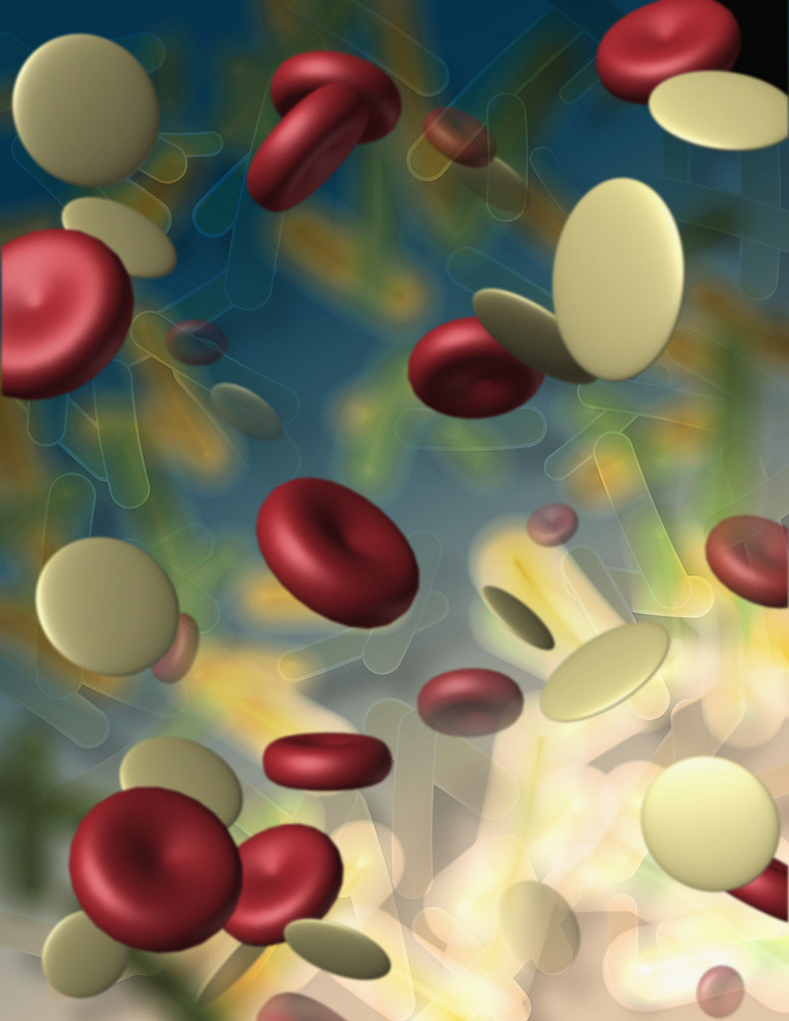
  - Means “ Large eater”
    - 2 types of Immunity
- Active immunity
- Passive immunity
  - Vaccines
    - Help immunize against bacteria and viruses
    - Can be made of antibodies or weakened/dead pathogen to make antibodies

